COMPARISON OF AREA 51 INSTALLATION
FROM 1968 AND 1998
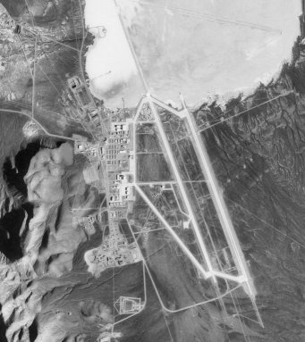
USGS U-2 FLYOVER  28 AUGUST, 1968 | RUSSIAN SPIN-2 SATELLITE  15 MARCH, 1998
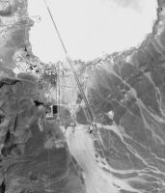 | 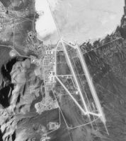
New Runway
A new runway has been constructed parallel to the east of the already existing one. Almost 3,800 meters long, the new runway doesn't extend onto the lake bed.
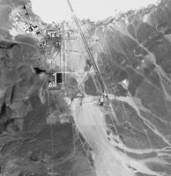 | 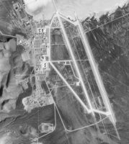
North Base - Hangars and Housing
The North Base has undergone much reconstruction since 1968. The four large hangars have been enlarged and the housing for base personnel has been completely rebuilt. The addition of more buildings has also taken place.
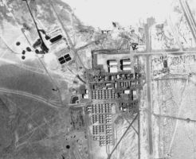 | 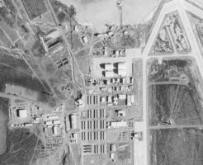
South Base Hangars
The hangars at this part of the installation have been improved, and the amount of hangars has also doubled. A major important addition is the large hangar noticeable at the top of the image.
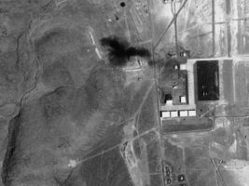 | 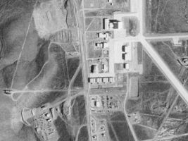
New Large Hangar
This new addition to the Area 51 installation has been very controversial. Images of this hangar have appeared in publications with a black triangular aircraft outside that resembles the hypersonic aircraft known as Aurora. Other researchers believe the hangar houses a recovered alien craft nicknamed the "mother ship."
South Base Tank Farm
The tank farm visible in the 1968 image, consisting of seven large storage tanks and three smaller tanks, remains visible in the 1998 image. The wide separation of the larger tanks is suggestive of fuel for aircraft. The 1998 image show significant new construction, incomplete as of the date of the image, suggesting a major enlargement in the support capacity of the Groom Lake facility.
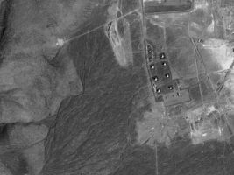 | 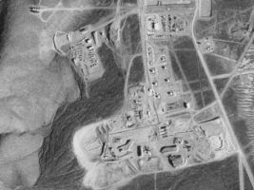
South Base - New Construction
An entirely new facility, of uncertain nature and purpose, was added to the Groom Lake complex at some point between 1968 and 1998.
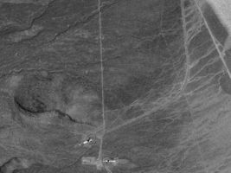 | 